**RIPHAH INTERNATIONAL UNIVERSITY, ISLAMABAD**



**Lab 3**

**Bachelors of Computer science – 5th semester**

**Subject:** Operating System Lab

**Submitted to:** Ma’am Kausar Nasreen Khattak

**Submitted by:** Munaza Malik

**Sap Id:** 44956

**Date:** 8th September, 2024

**Lab Task**

**Q1.** Make the following directory (03 Marks)

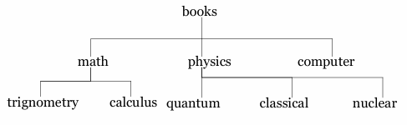

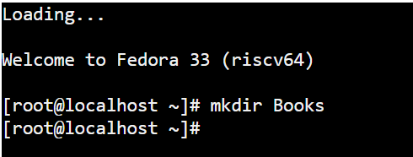

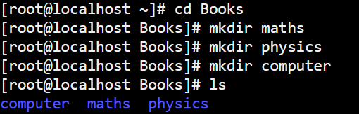

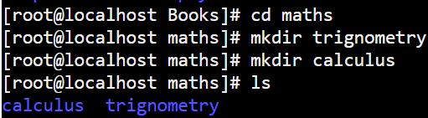

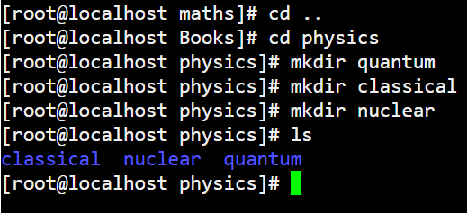

**Q2.** Which are the Linux Directory Commands? Explain the understanding of commands in your own words. Also define what is BASH? (02 Marks)

**Note:** Include screenshots, where required to illustrate your explanation.

**Linux Directory Commands:**

**pwd (Print Working Directory) :** Shows the full path of the current directory you are in.

**ls (list) :** Lists files and directories in the current directory.

**cd (change directory) :** Changes the current directory to another.

**mkdir (make directory) :** Creates a new directory.

**rmdir (remove directory) :** Deletes an empty directory.

**rm -r (Remove Recursively) :** Deletes a directory and all its contents.

**cp (copy) :** Copies files or directories to a new location.

**mv (move) :** Moves or renames files or directories.

**touch:** Creates an empty file or updates the timestamp.

**find (find) :** Searches for files or directories.

**What is BASH?**

BASH (Bourne Again Shell) is a command-line interface and scripting language for interacting with Linux systems. It interprets and runs the commands you type, and can also be used to write scripts for automating tasks. BASH is both a shell and a scripting language, providing a way for users to interact with the operating system through commands.

**Q3.** 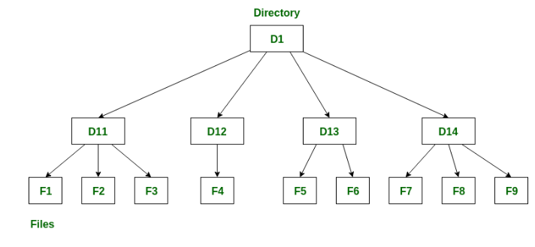

**Note:** Include screenshots, where required to illustrate your explanation. (02 Marks)

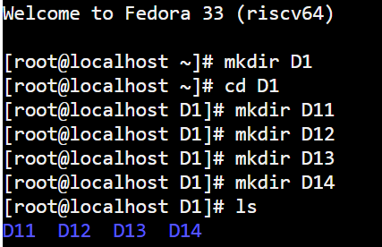

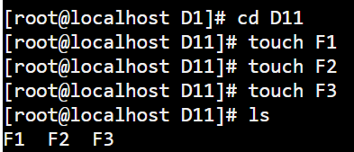

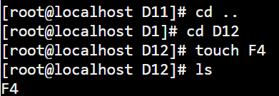

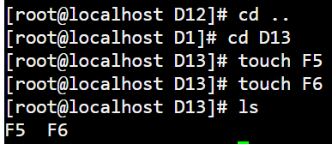

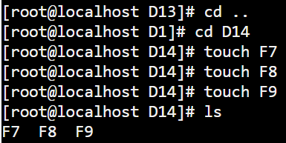

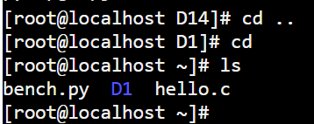

**Q4.** Make the following directory (03 Marks)

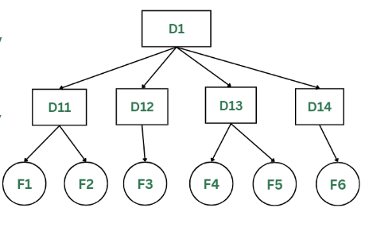

**Note:** Include screenshots, where required to illustrate your explanation.

